SETARI PROIECT JAVA

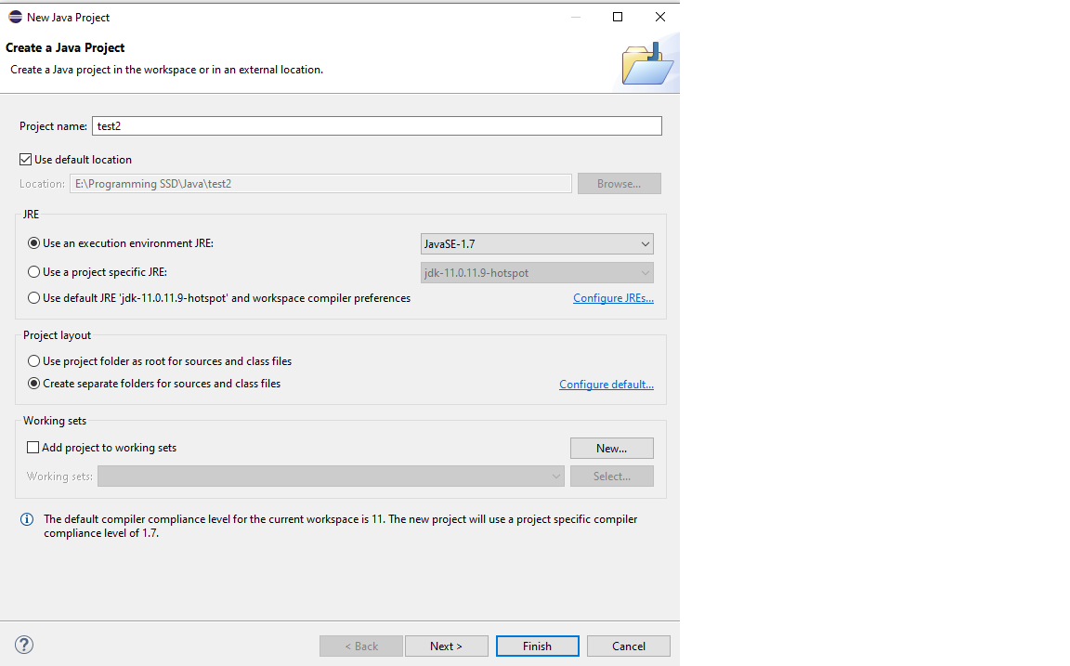

HELP 🡪 INSTALL NEW SOFTWARE 🡪

<https://download.eclipse.org/windowbuilder/1.9.6/>

http://download.eclipse.org/releases/2019-12/201912181000

JDK

https://adoptopenjdk.net/

